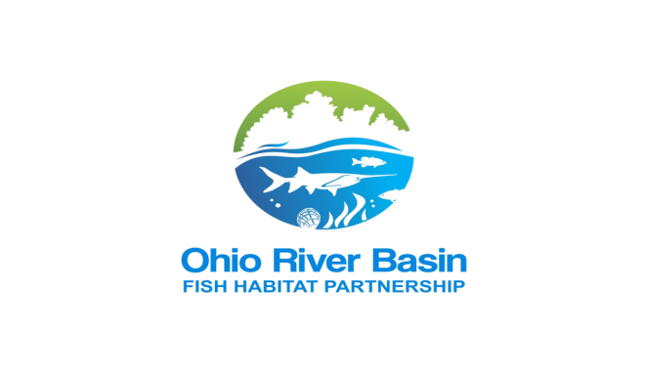



**Ohio River Basin Fish Habitat Partnership**

**FY 2020 Call for Project Proposals**

**Deadline – October 4, 2019**

Dear Conservation Partners,

The U.S. Fish and Wildlife Service (Service) anticipates receiving appropriations in FY 2020 to support the Ohio River Basin Fish Habitat Partnership (ORBFHP) and its efforts to complete on-the-ground, aquatic habitat protection, restoration, and enhancement projects. The Service and the ORBFHP recognize that a substantial amount of the protection, restoration and enhancement of aquatic habitat will be done at the local level by local watershed associations, municipalities, tribes, states and nongovernmental organizations. The Service and the ORBFHP will work with organizations to encourage local conservation actions that fit within the ORBFHP’s Strategic Plan priorities. A “project” is defined as an action that will protect, restore or enhance Ohio River Basin fish/mussel habitat. Project proposals will be reviewed and ranked by the ORBFHP Steering Committee. The Service will use the recommendations provided to them by the ORBFHP in making final decisions regarding project funds, and anticipates making final decisions regarding project selection by spring 2020.

Please use the following guidelines in this RFP to submit your proposal to Donovan Henry (Donovan_Henry@fws.gov) and Collin Moratz (Collin_Moratz@fws.gov) by **October 4, 2019**. For questions, please email or call Donovan or Collin, USFWS, at 618-997-6869, ext. 104 or ex. 122, respectively.

The Ohio River and its basin are of national significance in both geographic scope and the fish and mussel resources contained within them. The Ohio River is the second largest river in the United States as measured by its annual discharge. The basin also contains at least 350 species of fish and more than 120 mussel species, including a number that are federally listed. Sportfishing is a major recreational activity with over 2.5 million angling hours recorded and 2.8 million fish caught within just the main-stem Ohio River during past surveys. It was with these resources in mind, that the Ohio River Basin Fish Habitat Partnership (ORBFHP) coalesced from a meeting of approximately 50 federal and state agencies, NGOs, and academic representatives interested in the aquatic habitat of the Ohio River Basin.

The ORBFHP’s focus is embodied in its mission statement: *The Ohio River Basin Fish Habitat Partnership focuses protection, restoration, and enhancement efforts on priority habitat for fish and mussels in the watersheds of the Ohio River Basin for the benefit of the public.*

**The Ohio River Basin Fish Habitat Partnership will accept proposals for**

**Fiscal Year 2020 aquatic habitat projects in the Ohio River Basin as follows:**

**Priority Areas:**

Fish habitat protection and restoration projects that are within ORBFHP priority areas will be given primary consideration. Projects outside of these areas are still eligible (see map below):

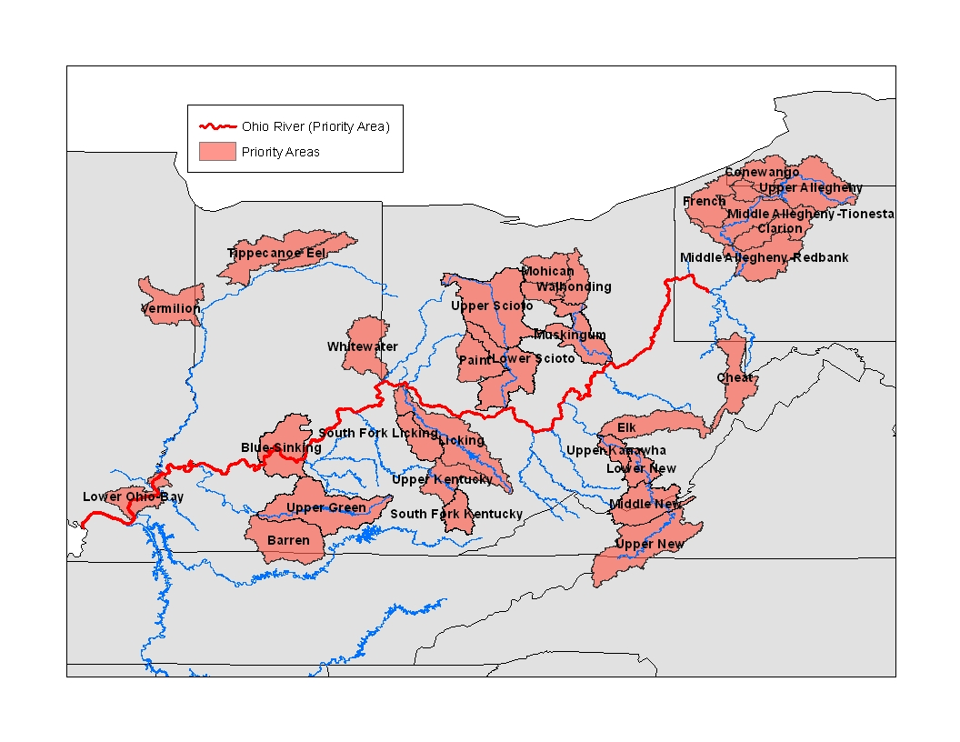

**Eligibility:**

* Projects must be within the Ohio River Basin.
* Ohio River Basin Fish Habitat Partnership (ORBFHP) funding requests typically range

between $10,000 and $60,000, but larger project requests can be submitted and will be

considered depending on funding levels.

* Federal agencies, states, tribes, tribal authorities, local governments, non-profits, for-

profits, and private individuals can all apply.

* Match and partner contributions of 3:1 are encouraged, but others will be considered. In-kind and federal match is allowed.
* Post-project monitoring is required. This requirement can be met by using existing state, federal, local, or other monitoring programs.
* Incomplete applications will not be accepted.
* Applications submitted after the deadline of midnight, October 4, 2019 will not be accepted.

**Fund Request Restrictions:** ORBFHP funding cannot be used for:

* Realty costs (e.g., lease or purchase interests in real property or to make rental or other land use incentive payments to landowners).
* Operation and maintenance of facilities or structures.
* Actions required by existing regulatory programs, except that funds may support activities under voluntary agreements that exceed regulatory requirements for conserving habitats (e.g., hydropower licensing in which the licensee enters into a voluntary agreement to restore habitat that exceeds regulatory requirements).

**Priority will be given to projects that address these factors in your online application:**

* Projects in **priority areas** and directly related to the focus of the ORBFHP’s Strategic Plan (Appendix 1).
* Address conservation or restoration actions where ORBFHP signature species are present (Appendix 1).
* Consider watershed-scale ecological and hydrological processes that affect fish habitat and fish populations.
* Are part of a watershed restoration effort that works to provide permanent solutions to the root cause of habitat decline.
* Are integrated and aligned with other conservation plans (e.g. State Wildlife Plans,

Watershed Management Plans, etc.).

* Evaluate their actions on target habitats, ecosystem processes and fish populations over time.
* Leverage resources from partners.
* Provide benefits to a broad spatial scope of aquatic resources, beyond the immediate project site (e.g. reconnect multiple miles of river)
* Identify measures of success and performance targets that are observable and amenable to

pre- and post- project monitoring.

* Include an outreach/education component in the local community.
* Where applicable, incorporate best management practices that:
  + - Ensure they will not spread invasive species
    - Use the most current science and technology for project design.
    - Incorporate climate change adaptation.

**Other Considerations:**

* If you have multiple projects that are different project types, please submit separate proposals for each project type. For example, a project that will restore fish passage in one stream or watershed in three different locations is considered one project, but a project that removes a fish passage barrier and restores a wetland downstream of the barrier is considered two projects.
* Fund recipients must follow federal requirements for accounting, National Environmental

Policy Act (NEPA), Endangered Species Act, State Historic Preservation Office (SHPO), and other applicable laws.

* ***Please note that additional information may be REQUIRED at a later date.***

**Additional Information about the Online Application Process**

Please include the following information in your proposal.

**Overview**

− Project title and type.

− Provide a project abstract in 500 characters or less.

− Identify project location. If your project includes multiple sites in a watershed, select a

latitude and longitude for one of those sites. You can provide additional information about project locations later in the application.

− Select the 12-digit Hydrologic Unit Code (HUC) for your project location. You may select

more than one watershed.

− Identify the state/federal agency responsible for fish management.

− Is land ownership Federal, State, County, City, Tribal, Private, or Other?

− Will public fishing access is available at the project site?

− Please include your congressional district as well as all congressional districts in which physical activities of the project will occur.

− Has NEPA been initiated? If so, to what extent?

− Has federally threatened/endangered species review with USFWS and/or state natural resource agency been completed?

− Has historical/cultural review with SHPO been completed?

**Contacts**

− Provide contact information for the project officer for this proposal, and co-officer if appropriate.

If known, please include DUNS number and EIN

**Funding**

− If federal funding has been received in the past, provide a general list of federal funding

sources in 350 characters or less.

− Were you required to submit an A-133 single audit for last fiscal year?

− Is your SAM.gov profile currently active?

− Are you enrolled in ASAP (Automated Standard Application for Payments)?

− Enter your project funding request and match. Applicants are encouraged to meet a three to

one match for proposed projects. Matching funds may be federal or non-federal, in-kind or cash that has been applied to the proposed project within 2 years of the start date of this proposal. Letters of intent may be requested from contributing partners before obligating funding.

− To provide budget information, you may use the federal form SF 424a for non-construction

projects or form SF 424c for construction projects. Please include a budget justification, including calculations for personnel allocation and descriptions of other expenses for all budget categories. Forms available at: <http://www.grants.gov/web/grants/forms/sf-424-family.html#sortby=1>

Alternately, you may attach a file indicating how ORBFHP funding money would be spent using an excel spreadsheet. Please itemize costs and rationale for costs with as much detail as possible (e.g. purchase of 100’ bottomless culvert = $22,500; labor for backhoe operation and planting vegetation (100hrs @ $25/hour) = $2,500). Please do not inflate or underestimate costs. Indirect costs cannot exceed 10% unless applicants have a negotiated indirect cost rate agreement established with the federal government. We encourage minimizing indirect costs (10% or less).

− Identify one or more ORBFHP priorities that your project addresses.

− Enter the aquatic species that your project benefits. Be sure to include all applicable

ORBFHP Signature Species (Appendix 1). Included species must be near enough project to be directly affected.

− Describe project objectives and methods using SMART format (Specific, Measurable,

Attainable, Realistic, and Time bound).

− Enter metrics that will be used to measure success for assessment and/or conservation

projects: conservation actions taken, number of aquatic populations assessed, total miles of in-stream/riparian habitat assessed, number of aquatic organism passage barriers removed or bypassed, number of acres of upland/wetland habitat assessed, number of miles reopened to fish passage.

− What are the root causes of habitat degradation? Use up to 250 characters to describe the root causes of habitat degradation in the project area and the causes your project will address.

**Management**

− What is your desired start date and anticipated project duration.

− Describe how the project is part of a watershed scale effort in 1,000 characters or less.

− Describe how the project will be monitored in 1,000 characters or less.

− You may provide additional information you feel is relevant to your proposal and not

covered elsewhere in 1,000 characters or fewer.

− Provide a map and photos of your project site.

− Please answer the following in fewer than 1,000 characters each:

1. Describe why you feel you and your organization are qualified to successfully complete all aspects of this project.

2. Describe any planned outreach or educational component(s) and partner(s) involved.

3. What methods will you use to promote the project if it is funded?

4. Will the project prevent the spread of invasive species, and if so, please describe how.

5. Describe how the project will use best management practices and/or use most current

science/technology.

6. Does the project incorporate strategies that will respond to climate change?

− You may include additional information that you feel is relevant to your proposal, including planning documents, additional information on project sites, project fact sheets, etc. Please limit uploaded materials to 10 pages total. Links to a website that has additional information are welcome.

**Partnership Info**

− Please include existing plans that your project addresses or is integrated with. Links to websites of partnering organizations are appreciated.

Please send your completed proposal to Donovan Henry (Donovan_Henry@fws.gov) and Collin Moratz (Collin_Moratz@fws.gov). Please e-mail or call, (618) 997-6869, with any questions.

**Appendix 1. ORBFHP Conservation Targets and Strategic Actions**

**ORBFHP Conservation Targets and Signature Species:**

Conservation targets selected by the ORBFHP include:

• Headwater and small streams (watersheds < 200 sq miles) and the signature long-ear sunfish, and rainbow and orangethroat darters

• Medium rivers (watersheds 200-3,681 sq miles) and the signature fish of smallmouth and spotted bass, logperch, and tippecanoe darters

• Large and great rivers (watersheds > 3,681 sq miles) and the signature fish of sauger, paddlefish, sturgeon, and blue suckers

• Off-channel systems (e.g. oxbows, sloughs, and other secondary channels) and the signature fish of largemouth bass and pickerel

• Native aquatic vegetation

• Native mussels (fluvial dependent, non-pool species)

**ORBFHP core list of specific habitat protection/restoration strategic actions:**

Strategy 1 – Identify and protect intact and healthy waters.

**1.1 Identify the key lands along priority intact and high quality stream and off-channel systems necessary to maintain the physical and ecological processes that supply the key ecological attributes of selected conservation targets.**

**1.2 Work with appropriate state and federal agencies, municipalities, and NGOs to protect lands identified in 1.1 along high priority streams and off-channel systems.**

**1.3 Identify the key hydrologic parameters needed to sustain the ecological needs of conservation targets in priority streams and off channel systems.**

**1.4 Work with appropriate governmental agencies, water users and NGOs to prevent significant future hydrologic alteration within high priority streams and off-channel systems identified in 1.3.**

**1.5 Develop guidance on appropriate locations for large water withdrawals and electrical generation sites that avoid siting at critical locations within key systems.**

Strategy 2- Restore natural variability in river and stream flows and water surface elevations in floodplain features (oxbows, secondary channels, etc).

**2.1 Identify priority stream and off-channel systems impacted by hydrologic alteration within the Ohio River System.**

**2.2 Work with dam operators, municipalities, and state agencies on priority stream**

**systems to develop and adopt ecologically based flow management regimes that improve the status of selected conservation targets.**

**2.3 Remove or modify (where possible) dams and/or other structures that significantly alter natural stream hydrology.**

**2.4 Restore off-channel systemsimpacted by hydrologic alteration within the Ohio River System.**

**2.5 Improve system hydrology in key floodplain areas along priority streams by restoring river connectivity to these areas.**

Strategy 3 – Reconnect fragmented river, stream, reservoir, coastal, and off-river habitats to allow access to historic spawning, nursery and rearing grounds.

**3.1 Physically remove or modify (where possible) dams and other barriers that prevent aquatic organism movement.**

**3.2 Modify operational regimes to improve fish and aquatic organism passage through locks, dams and other structures.**

**3.3 Reconnect key floodplain and off-river spawning habitat along priority streams to allow access for signature conservation targets.**

Strategy 4 – Reduce and maintain sedimentation, phosphorus and nitrogen runoff to river, stream, and off-river habitats at a level within 25% of the expected natural variance in these factors or above numeric State Water Quality Criteria.

**4.1 Within priority stream systems, identify those areas which are key contributors to excess nutrification.**

**4.2Within priority stream systems, determine the appropriate combination of land acreage identified in 4.1 and BMPs needed to reduce nutrification in streams.**

**4.3 Within priority stream systems, facilitate the implementation of BMPs on land acreages identified in 4.2 to reduce nutrification in streams.**

Strategy 5- Reduce other key pollutants or degrading environmental conditions (acid drainage, heavy metals, altered temperatures, or oxygen levels) in degraded priority stream habitat to a level within 25% of natural rates or above numeric Stream Water Quality criteria.

**5.1 Within priority stream systems identify key sources of pollutants or other environmentally degrading conditions.**

**5.2 Within priority stream systems identify and facilitate the implementation of BMPs/restoration techniques to reduce degradation from key sources.**

Strategy 6- Reduce the potential for invasive species impact through prevention and control measures at the basin-level and within priority systems.

**6.1 Identify and prioritize potential sources and associated invasive species.**

**6.2 Engage with appropriate agencies and entities to develop prevention programs/measures to stop the introduction/spread of invasive species.**

**6.3 Facilitate the implementation of prevention programs/measures developed in 6.2 with appropriate agencies and entities. As an example identify physical barriers or environmental conditions within priority streams that likely serve (or could serve) as barriers for invasive species and work with states to develop protection measures to preserve (or augment) these conditions.**

**6.4 Identify appropriate methods of controlling already present invasive species and implement in ORB streams.**